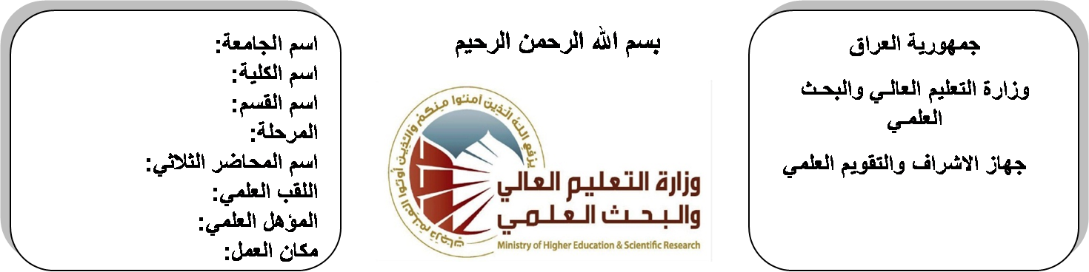

**Republic of Iraq**

**Ministry of Higher Education**

**& Scientific Research**

**University: Diyala University**

**College: College of Engineering**

**Department: Electronic Engineering**

**Stage: Second stage**

**Lecturer name: ABBAS SALMAN HAMEED**

**Qualification: Msc**

**Place of work: Electronic Dept.**

**(( Annual teaching plan form))**

|  |  |  |  |  |
| --- | --- | --- | --- | --- |
| **Lecturer Name** | **ABBAS SALMAN HAMEED** | | | |
| **Email** | **abbasfuture@yahoo.com** | | | |
| **Subject** | Computer Programming II | | | |
| **Aims** | **The aim of this subject is to make the students ready to undestand and comprehend the scientific theories and their applications related to their field of the study.** | | | |
| **Textbooks** | C language by James M.ortega. | | | |
| **Additional Textbooks** | **How to program C language by prentice & hill.** | | | |
| **Assessments** | **First Semester** | **Second Semester** | **Laboratory** | **Final Exam** |
| 20% | 20% | 10% | 50% |
| **Notes** |  | | | |

**Schedule Weekly Lessons - First Semester**

|  |  |  |  |  |
| --- | --- | --- | --- | --- |
| **Week** | **Date** | **Lectures** | **Lab. Experments** | **Notes** |
| 1 | **27/9/** | A brief history importance of C++ |  |  |
| 2 | **4/10/** | Simple program of C++ |  |  |
| 3 | **11/10/** | Simple program of C++ |  |  |
| 4 | **18/10/** | Identification, declaration |  |  |
| 5 | **24/10/** | Identification, declaration |  |  |
| 6 | **1/11/** | Data types, Expressions, Operators, Arithmetic |  |  |
| 7 | **8/11/** | Data types, Expressions, Operators, Arithmetic |  |  |
| 8 | **15/11/** | logical Assignment, Relation of Operator bitwise |  |  |
| 9 | **22/11/** | ternary, I/O operation |  |  |
| 10 | **29/11/** | cin>> statement, cout<<statement, main () function, semi column |  |  |
| 11 | **6/12/** | Basic program control (for) statement, nesting loop, (while) statement |  |  |
| 12 | **12/12/** | (Do, while) nesting loop, (if) statement, (if …..else) statement, switch( ) statement break |  |  |
| 13 | **20/12/** | Arrays, 1-D arrays initialization, declaration storing |  |  |
| 14 | **27/12/** | Multidimensional arrays initialization |  |  |
| 15 | **3/1/** | Declaration application of 2D- arrays |  |  |
| 16 | **10/1/** | Declaration application of 2D- arrays |  |  |
| Half Year holiday | 15/1/ to  1/2/ |  |  |  |

**Lecturer Signature Head of Dept. Signature Dean Signature**

**Schedule Weekly Lessons - Second Semester**

|  |  |  |  |  |
| --- | --- | --- | --- | --- |
| **Week** | **Date** | **Lectures** | **Lab. Experments** | **Notes** |
| 1 | **21/2/** | character arrays, Arrays & pointers |  |  |
| 2 | **28/2/** | Creating pointer |  |  |
| 3 | **6/3/** | Declaration pointer |  |  |
| 4 | **13/3/** | initialization pointer & variable types |  |  |
| 5 | **20/3/** | Application on pointers |  |  |
| 6 | **27/3/** | A brief history importance of MATLAB |  |  |
| 7 | **3/4/** | Simple program of MATLAB |  |  |
| 8 | **10/4/** | Variable, numbers, operations, functions |  |  |
| 9 | **17/4/** | plots in matlab |  |  |
| 10 | **24/4/** | plots of points, axes label, graph title |  |  |
| 11 | **1/5/** | drawing multi point in the same graph |  |  |
| 12 | **8/5/** | Basic program control (for) statement |  |  |
| 13 | **15/5/** | nesting loop, (if) statement |  |  |
| 14 | **22/5/** | (if …..else) statement |  |  |
| 15 | **29/5/** | Arrays, 1-D arrays initialization |  |  |
| 16 | **2/6/** | 2D- arrays, matrix operations in matlab |  |  |

**Lecturer Signature Head of Dept. Signature Dean Signature**